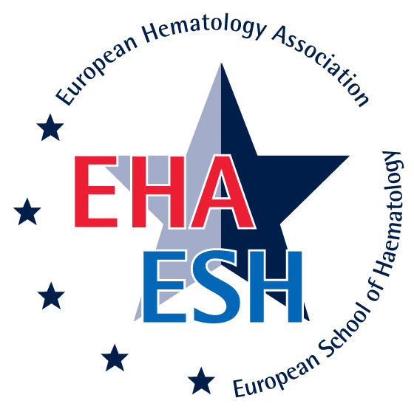
(Type I Hematology Tutorial)
Diagnostic Work-Up of Hematological Malignancies
FOCUS ON CHRONIC MALIGNANCIES

November 6-8, 2009 / Vienna, Austria

Chairs: G. Zini, B. Bain, R. Foà

Program

Friday, November 6, 2009

08h30-09h00 Registration
09h00-09h15 Welcome D. Jasmin (Paris)
09h15-10h15 Morphology in LPDs & Question time G. Zini (Rome)
10h15-11h00 2 Tutored clinical cases & Question time G. Zini (Rome)

11h00-11h30 Coffee Break

11h30-12h30 Flow-cytometry in LPDs & Question time A. Orfao (Salamanca)
12h30-13h15 2 Tutored clinical cases & Question time A. Orfao (Salamanca)

13h15-14h15 Lunch

14h15-15h30 1st self-evaluation session & Discussion G. Zini & A. Orfao
15h30-16h30 Clinics/therapeutics in CLL & Question time E. Montserrat (Barcelona)

16h30-16h45 Coffee Break

16h45-17h45 2 Tutored clinical cases & Question time M. Rozman (Barcelona)

Saturday, November 7, 2009

09h00-10h00 Genetics and molecular genetics in B-LPDs R. Foà (Rome)
& Question time
10h00-10h45 2 Tutored clinical cases & Question time R. Foà (Rome)

10h45-11h15 Coffee Break

11h15-12h30 2nd self-evaluation session & discussion M. Rozman & R. Foà
12h30-13h30 Morphology in MPNs and MDS/MPNs & Question time B. Bain (London)

13h30-14h30 Lunch

14h30-15h15 2 Tutored clinical cases & Question time B. Bain (London)
15h15-16h15 Flow-cytometry in MPDs & Question time MC. Béné (Nancy)

16h15-16h30 Coffee Break

16h30-17h15 2 Tutored clinical cases & Question time MC. Béné (Nancy)
17h15-18h30 3rd self-evaluation session & Discussion B. Bain & MC. Béné

Sunday, November 8, 2009

09h00-10h00 Genetics and molecular genetics in MPNs
& Question time T. Haferlach (Munich)
10h00-10h45 2 Tutored clinical cases & Question time T. Haferlach (Munich)

10h45-11h15 Coffee Break

11h15-12h15 Clinics/therapeutics in CML & Question time G. Saglio (Turin)
12h15-13h00 2 Tutored clinical cases & Question time G. Saglio (Turin)

13h00-14h00 Lunch

14h00-15h15 4th self-evaluation session & Discussion T. Haferlach & G. Saglio
15h15-16h15 Clinics/therapeutics in other MPNs
& Question time S. McCann (Dublin)

16h15-16h30 Coffee Break

16h30-17h15 2 Tutored clinical cases & Question time S. McCann (Dublin)
17h15-18h30 5th self-evaluation session & Discussion S. McCann
& P. Bettelheim (Vienna)
18h30 Final remarks R. Foà

End of the meeting

