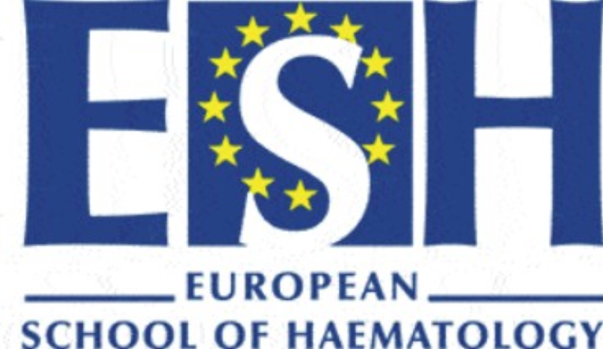

INTERNATIONAL CONFERENCE ON MYELODYSPLASTIC SYNDROMES
Chairs: M. Cazzola, P. Fenaux, E. Hellström-Lindberg
Mandelieu, France, Oct 22-25, 2009

PROGRAMME

Thursday, Oct 22, 2009

Session 1 Bone marrow failure and childhood MDS. - Chair: H. Hasle
14.00-14.45 Pathophysiologic links between marrow failure, genomic instability,
and clonal évolution N. Young (Bethesda)
14.45-15.30 Childhood MDS and JMML; biology, diagnosis, and treatment H Hasle (Aarhus)
15.30-16.00 Cases and questions to panel Panel

16.00-16.30 Coffee break

Session 2 Diagnostic work-up of MDS - Chair: A.Porwit

16.00-16.30 Diagnosis and WHO 2008 classification of MDS A. Porwit (Stockholm)
16.30-17.00 Cytogenetics and molecular genetics in MDS B. Schlegelberger (Hannover)
17.00-17.20 Role of flow cytometry in MDS diagnostics A. A. van de Loosdrecht
(Amsterdam)
17.20-17.40 The application of array-based technology in MDS diagnostics D. Bowen (Leeds)
17.40-18.00 New aspects of MDS and “not yet MDS” morphology B. Bain (London)
18.00-18.30 Cases and questions to panel Panel

19.30-20.30 Posters and welcome reception

20.30 Dinner

Friday, Oct 23, 2009

Session 3 Epidemiology and clinical evaluation of MDS - Chair: L. Malcovati
9.00-9.30 Epidemiology D. Bowen (Leeds)
9.30-10.00 Clinical presentation M. Jadersten (Stockholm)
10.00-10.30 Prognosis and risk assessment; L. Malcovati (Pavia)
10.30–11.00 Cases and questions to panel A. Porwit (Stockholm) &
E. Hellström-Lindberg (Stockholm)

11.00-11.30 Coffee Break

Session 4 Myelodysplastic/myeloproliferative neoplasms - Chair: M. Cazzola
11.30-12.00 Chronic myelomonocytic leukaemia D. Bowen (Leeds)
12.00-12.20 TET2 mutations in MDS and MPNs M. Fontenay (Paris)
12.20-12.40 TET2 mutations in MDS and MPNs J.H Janssen (Nijmegen)
12.40-13.00 Refractory anemia with ringed sideroblasts and
excessive thrombocytosis M. Cazzola (Pavia)

13.00-14.30 Lunch discussions at defined tables
Session 5 Overlapping syndromes - Chair: D. Bowen

14.30-15.00 MDS with bone marrow fibrosis L. Malcovati (Pavia)
15.00-15.30 tMDS E. Estey (Seattle)

15.30-16.00 NPM1 – rolein AML and MDS C. Mecucci (Perugia)

16.00-16.30 Coffee break

Session 6. MDS research. What have we learned? - Chair J. Maciejewski

16.30-17.00 Array-based techniques J. Maciejewski (Cleveland)
17.00-17.30 Epigenetic studies K. Gronbaek (Copenhagen)
18.00-18.30 Animal models – genetically modified mice R.A. Padua (Paris)
18.30-19.00 Somatically modified cell and animal models A. Karsan (Vancouver)
18.30-19.00 Questions to panel

20.00-21.00 Drinks, snacks and poster presentation

21.00-22.30 Dinner

Saturday, Oct 24, 2009

Session 7: Pathophysiology - Chair: P. Fenaux

9.00-9.30 Apoptosis and erythroid failure in low-risk MDS E. Hellström-Lindberg (Stockholm)
9.30-10.00 Molecular biology and genetic pathways in MDS J. Maciejewski (Cleveland)
10.00-10.30 Molecular biology and genetic pathways in MDS/MPN M. Fontenay (Paris)
10.30-11.00 Clonal evolution and leukaemic transformation S. Boehrer (Paris)

11.00-11.30 Coffee break

Session 8: Biology and treatment of 5q-syndrome - Chair: A. Karsan

11.30-12.00 The molecular pathogenesis of MDS with the del (5q) J. Boultwood (Oxford)
12.00-12.20 Treatment of 5q-; the pro-lenalidomide view P. Fenaux (Paris)
12.20-12.40 Treatment of 5q-; the con-lenalidomide view E.Hellstrom-Lindberg
(Stockholm)
12.40-13.00 Treatment of 5q-; cases and panel discussion panel

13h00-14.30 Lunch discussions at defined tables

Session 9: Supportive care in MDS - Chair: G. Mufti
14.30-15.00 Transfusion therapy in MDS L. Malcovati (Pavia)
15.00-15.30 Iron metabolism and transfusion iron overload M. Cazzola (Pavia)
15.30-15.50 Treatment of transfusion iron overload in MDS; the pro-chelation view C. Rose (Lille)
15.50-16.10 Treatment of transfusion iron overload in MDS; the con-chelation view D. Bowen (Leeds)
16.10-16.30 Management and treatment of thrombocytopenia G. Garcia-Manero (Houston)

16.30-17.00 Coffee Break
Session 10: Curative treatment - Chair T. De Witte
17.00-17.30 Ablative SCT ± preceding chemotherapy T. De Witte (Nijmegen)
17.30-18.00 Non myelomablative stem cell transplantation N. Kroeger (Hamburg)
18.00-18.30 Treatment of paediatric MDS C. Niemeyer (Freiburg)
18.30-19.00 Cases and questions to panel Panel

20.30 Conference dinner

Sunday, Oct 25, 2009

Session 11: Treatment of low-risk MDS - Chair: E. Hellstrom-Lindberg

08.30-9.00 Growth factor treatment of low-risk MDS M. Jadersten (Stockholm)
09.00-9.20 Immunosupression in low-risk MDS N. Young (Bethesda)
09.20-9.40 Low-risk MDS: ongoing trials at clinical trials.gov M. Cazzola (Pavia)
09.40-10.30 Leukaemia Net Guidelines and cases low-risk MDS Panel

10.00-10.30 Coffee break

Session 12: Non-curative treatment of high-risk MDS - Chair: G. Garcia-Manero

10.30-10.50 Induction chemotherapy and low-dose chemotherapy M. Lübbert (Freiburg)
10.50-11.20 Azacytidine in MDS P. Fenaux (Paris)
11.20-11.40 Decitabine in MDS M. Lübbert (Freiburg)
11.40-12.10 High-risk MDS: HIDACi and ongoing trials at clinical trials.gov G. Garcia-Manero (Houston)
12.10-13.00 Leukaemia Net Guidelines and cases high-risk MDS Panel

13.00 Adjourn Chairs

