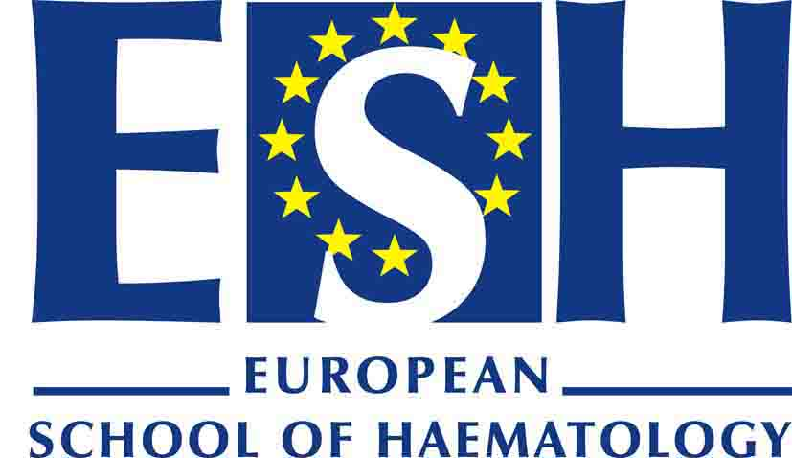

IMMUNE THROMBOCYTOPENIA

30th April – 2nd May 2010

Lisbon, Portugal

Chairs : D. Provan, A. Newland, D. Kuter, D. Cines, J. Semple

Preliminary programme

Friday 30th April

Morning : Basic Science of ITP - Chair: J. Semple

Megakaryocyte differentiation and platelet production A. Weyrich (Salt Lake City)

Autoimmune mechanisms and T regulatory cell K. Yazdanbakhsh (New York)
disturbances in ITP

Mouse models of ITP J. W Semple (Toronto)
Peptide therapy for patients with ITP S. Urbaniak (Aberdeen)
Afternoon : Clinical Dilemmas - Chair: Dr Provan
Unravelling secondary ITP D. Cines (Philadelphia)
A patient journey C. Black (London)
How useful is the indium labelled platelet survival study? A. Sarpatwari (London)
Splenectomy – best option for induction of durable
remission in chronic ITP? H. Wadenvik (Gothenburg)

Saturday 1st May

Morning : Novel Therapeutics - Chair: D. Kuter

TPO mimetics - old and new (review the new molecules, D. Kuter (Boston)
how they work, rationale for their use in ITP and liver
disease, potential adverse effects such as fibrosis)

Clinical studies with TPO mimetics - update all new data J. Bussel (New York)
on eltrombopag, AKR501 and romiplostim

Anti-CD20 monoclonal antibodies – old and new B. Godeau (Créteil)
(review mechanism and data for their use in ITP –
main focus is on rituximab but would also discuss
the newer agents veltuzamab and ofatumamab)

Novel therapies that alter Fc receptors A. Lazarus (Toronto)
(review of how IVIG works and how newer modified
sialyated IVIG upregulates oFcgRIIb, inhibitors of FcRN
system and syk kinase inhibition of Fc receptors)

Afternoon : Free Communications - Chair: A. Newland

5 short communications : 10 minute-presentation followed by a 5 minute-discussion

Sunday 2nd May

Morning : The Future - Chair: D. Cines

FC Receptors R. Clynes (New York)

B-cell receptor editing and autoantibody production: E. Meffre (New Haven)
Nailing the immune defect in ITP

CTL-mediated ITP B. Olsson (Gothenburg)

Future Therapies A. Newland (London)

