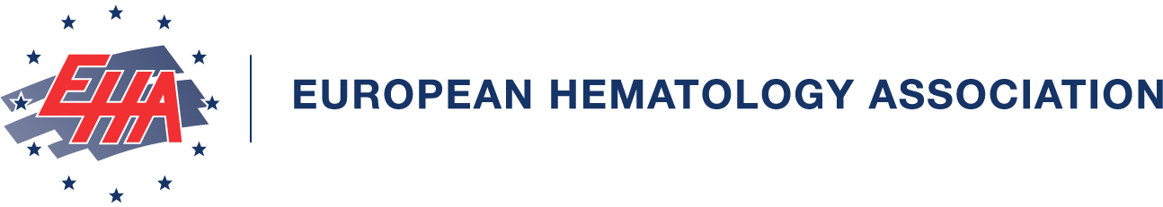

Dear Delegate of XIIIth Slovak and Czech conference on hemostasis and thrombosis with international participation,

We are pleased to inform you that as a participant of the XIIIth Slovak and Czech conference on hemostasis and thrombosis with international participation, you are eligible to receive European Hematology Association (EHA) Continuing Medical Education credit points. You will be able to claim your CME credits online as of April 8, 2006.

TO CLAIM YOUR CME POINTS:

- Go to www.ehaweb.org and select the CME link on top of the page
- From the CME home page, select the Claim Credits page at the top
- I have a CME account: you may use the link login on this page
- I do not have a CME account: you may open an account by using the link register here on this page

- Click on Select meeting in the left menu
- Select the XIIIth Slovak and Czech conference on hemostasis and thrombosis with international participation from the list
- - Enter your PERSONAL LOG IN CODE– ( 2006 Personal ID number)
- Answer the general questions regarding this meeting
- Click  at the bottom of the page to continue to Claim Credits › Select Sessions
- Evaluate the sessions that you have attended from 1–10. (10 is the highest score)

- Click at the bottom of the page to view your personal account. The system will automatically save your information after you have left the page

Monique Davidse
CME Helpdesk
cme@ehaweb.org
T 0031 10 4045621
F 0031 10 4361817
Open from:
Monday to Friday
9hrs 00 till 17hrs 00

Central European Time

Further information on the European Hematology Association CME system is available at www.ehaweb.org or at cme@ehaweb.org

